# Trip@Us - Your Friendly Travel Planner

Hello Gordon, please find your curated itineary for your Singapore visit below :).   
   
 We provide a detailed day by day breakdown of your trip to some of the places we know you will love. And what's more, our core algorithm optimised your travelling distance so that you can spend more time at the places you love :)

# Day 1

* Cable Car to Sentosa Island: Leisure & Attractions & Beaches
* 313@Somerset Mall
* Bugis Junction Mall
* CHIJMES Singapore
* Esplanade Theatre

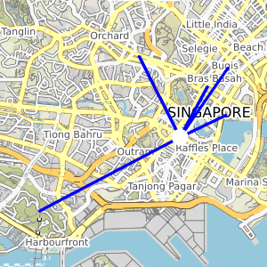

# Day 2

* Lau Pa Sat Singapore
* ION Orchard Mall
* Marina Barrage
* Gardens by the Bay
* Old Supreme Court Singapore

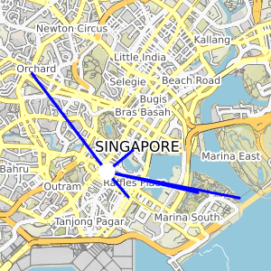

# Day 3

* Pinnacle@Duxton
* Pulau Ubin & Singapore Islands
* Orchard Central
* Peranakan Museum Singapore: History & Culture
* Raffles Statue

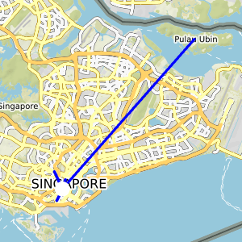

# Day 4

* S.E.A. Aquarium
* The Centrepoint
* Singapore Flyer in Sentosa Island
* Thian Hock Keng Temple Singapore

